|  |  |
| --- | --- |
| **Experiment Number** | **06** |
| **Date of Experiment** | 09/10/2023 |
| **Date of Submission** | 30/10/2023 |
| **Name of the student** | **MANODEEP RAY** |
| **Roll Number** | **2230028** |
| **Section** | ECS-01 |

**Aim of The Experiment :-**

Overview of DSP processor kit and Code Composer Studio (CCS v-5) & generation of various types of signals using (analysis plots using AIC-23 Codec) DSK-TMSC6713 processor kit.

**Equipment and Software Required:-**

The Equipment and Software required are as follows:

* DSP processor kit ( DSK-TMSC6713 processor kit )
* Code Composer Studio (CCS v-5)
* AIC-23 Codec

**Code:**

1. For unit impulse signal:

// 2230033 , 2230028 , 2230046 Unit step Exp 6_1//

#include<stdio.h>  
int n,k;  
int N=30;  
int y[30];  
void main()  
{  
for(k=0;k<=30;k++)  
{  
y[k]=0;  
}  
y[0]=1;  
for(n=0;n<=N;n++)  
{  
printf("%d\n",y[n]);  
}  
}

1. For unit step signal:

// 2230033 , 2230028 , 2230046 Unit step Exp 6_1//  
#include<stdio.h>  
int n,k;  
int N=30;  
int y[30];  
void main()  
{  
for(k=0;k<=30;k++)  
{  
y[k]=1;  
}  
for(n=0;n<=N;n++)  
{  
printf("%d\n",y[n]);  
}  
}

1. For ramp step signal:

// 2230033 , 2230028 , 2230046 Unit step Exp 6_1//  
#include<stdio.h>  
int n,k;  
int N=30;  
int y[30];  
void main()  
{  
for(k=0;k<=30;k++)  
{  
y[k]=k;  
}  
for(n=0;n<=N;n++)  
{  
printf("%d\n",y[n]);  
}  
}

**Block diagram:**

1. **For Unit Impulse** **Signal** **(2230028)**

1.1. Console output:

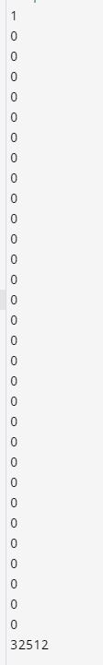

1.2. Graph (Discrete):

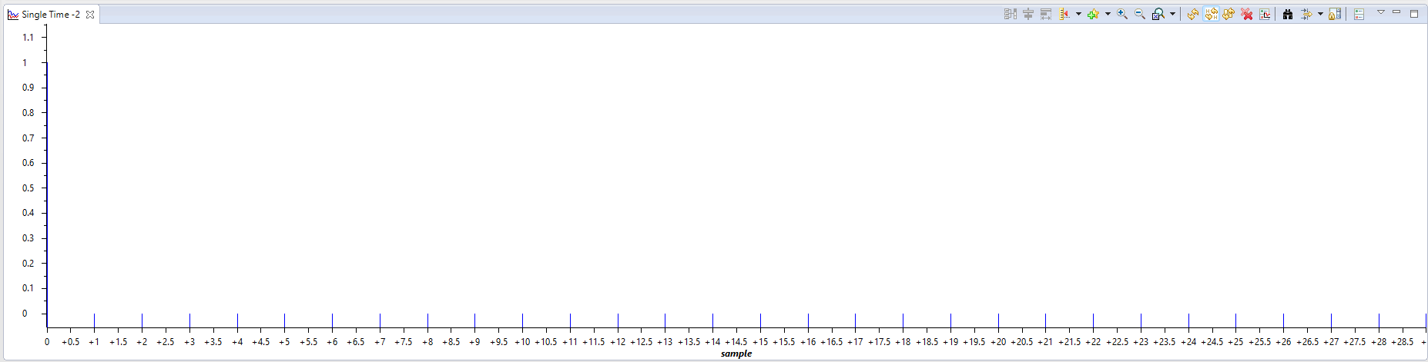

1.3. Graph (Line):

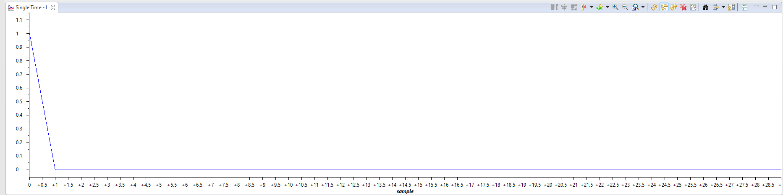

1. **For Unit Step** **Signal** **(2230028)**

2.1. Console output:

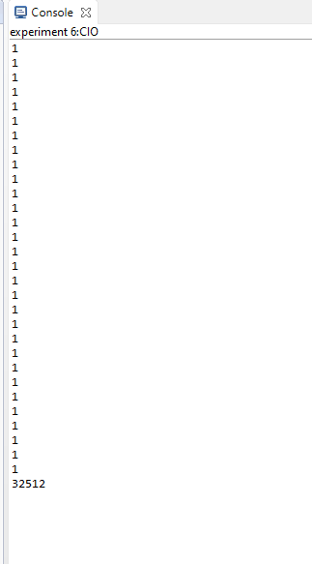

2.2. Graph (Discrete):

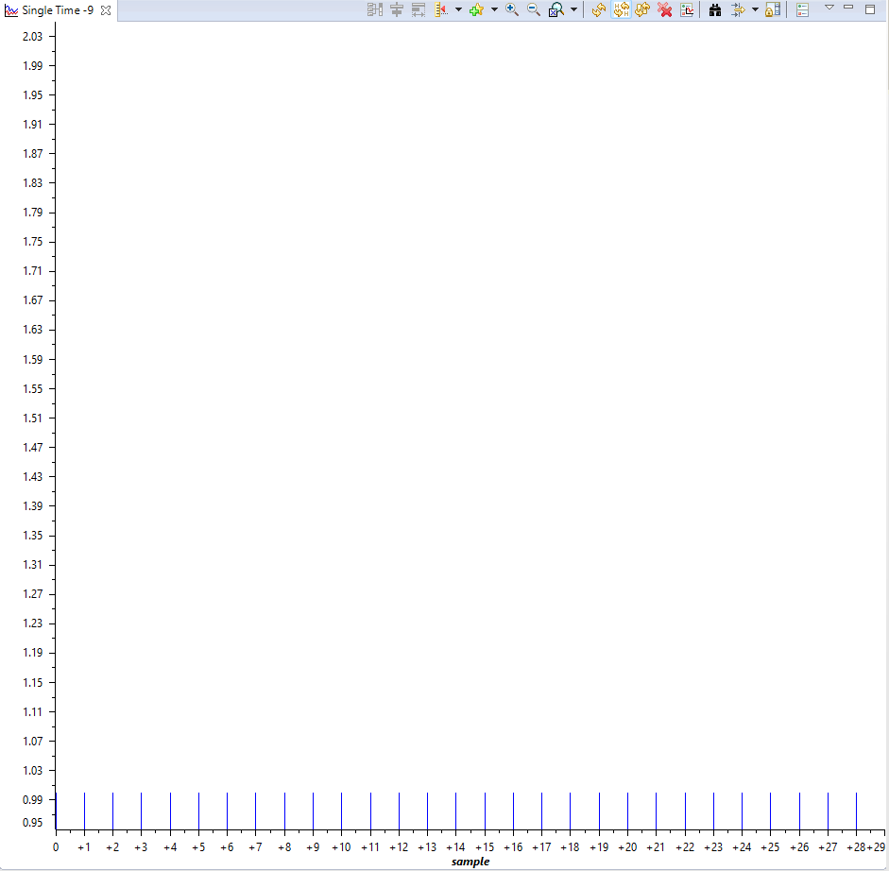

2.3. Graph (Line

):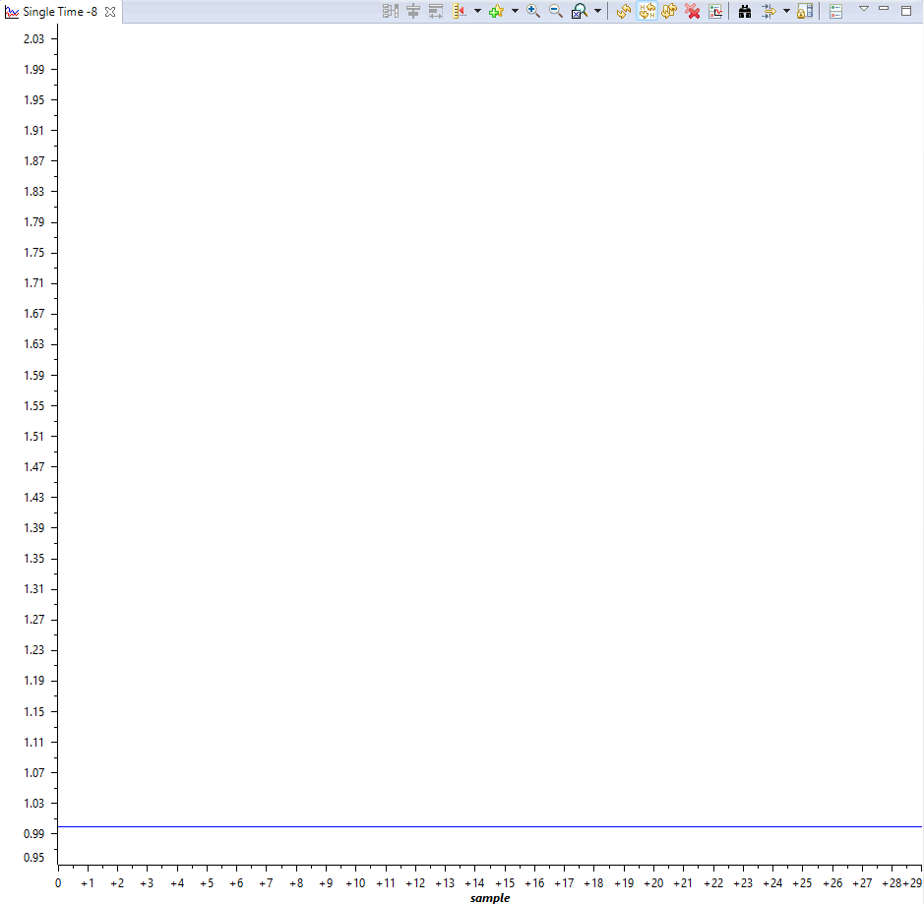

1. **For Ramp** **Signal** **(2230028)**

3.1. Console output

: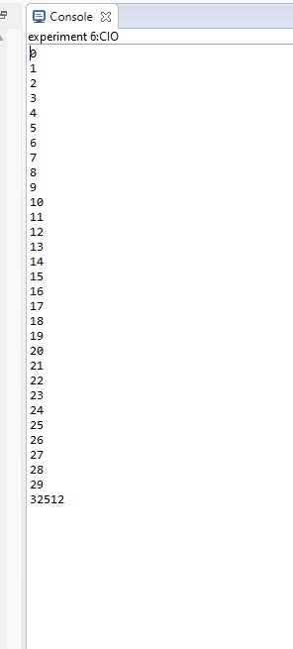

3.2. Graph (Discrete):

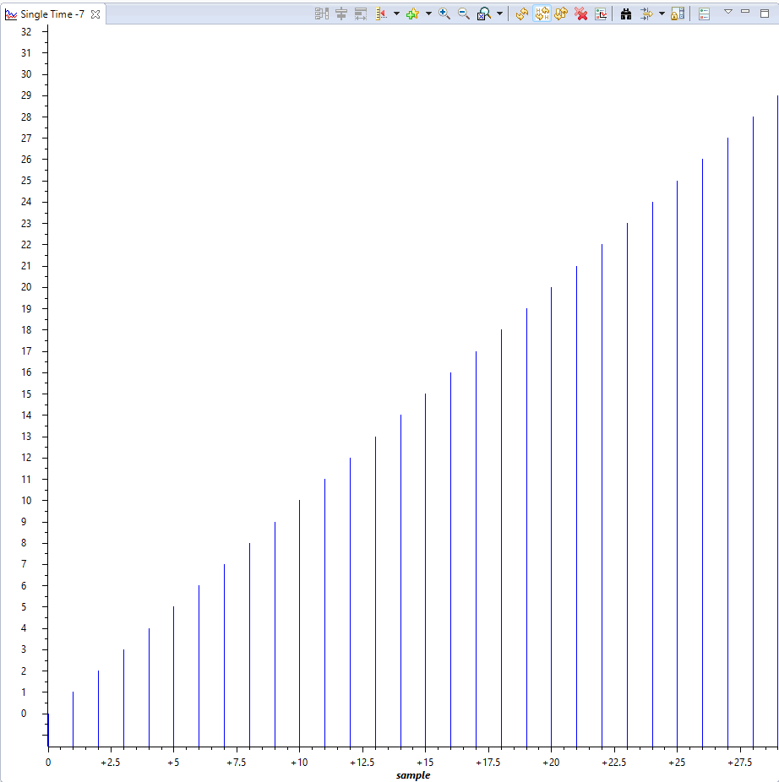

3.3. Graph (Line)

: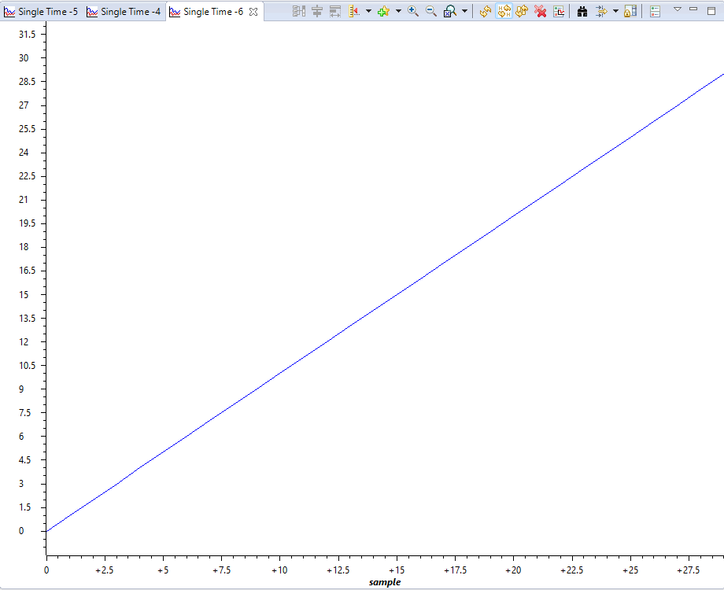

**Discussion or Inference of the experiment:**

In this experiment , we used a DSP processor kit ( DSK-TMSC6713 processor kit )

for generating Unit impulse , Unit step and Ramp signal with the help of CCS v-5 & AIC-23 Codec.

We scripted the code in C programming Language. We also generated both discrete and line graphs for the aforementioned signals.

**Conslusion:**

This experiment taught us how to use setup a DSP processor kit (DSK-TMSC6713) , connect the kit to the computer and run code on the hardware using CCS. We used theory of ‘for’ loops and array implementations in C programming for performing the experiment and analysed the plots and console outputs. We learnt about the nature and function of the aforementioned signals.